|  |  |  |  |
| --- | --- | --- | --- |
| **Use Case** | **Description** | **<<include>>** | **<<extend>>** |
| Login | To utilize all this app's capabilities, users must log in. | Authentication: Every time a user tries to access the program; they must verify their login information. | Registration: If a user does not already have an account, they can create one. |
| Register | Those who want to establish an account must first register. | Before the account may be activated, the user must be genuine. |  |
| Book  appointments | The user could arrange appointments. | Login: Prior to scheduling an appointment, the user needs to log into their account. |  |
| Dashboard | All users, including administrators, doctors, and patients, can access dashboards. | Activity: The dashboard's feature lets users keep an eye on their activities. |  |
| Settings | Each user would be able to change the profile linked to their account. | Update information: Customers can update their information by changing the settings. |  |

**Database connection (MYSQL)**

**Functionality Review**

**The main page and welcome page for the healthcare market trends and sickness dashboard**

**The full dashboard's second page shows the healthcare market trends unique to the ailment.**

**The dashboard's third page shows the entire wait list for healthcare market developments.**

**The page and welcoming space for the healthcare industry's developments and documentation.**

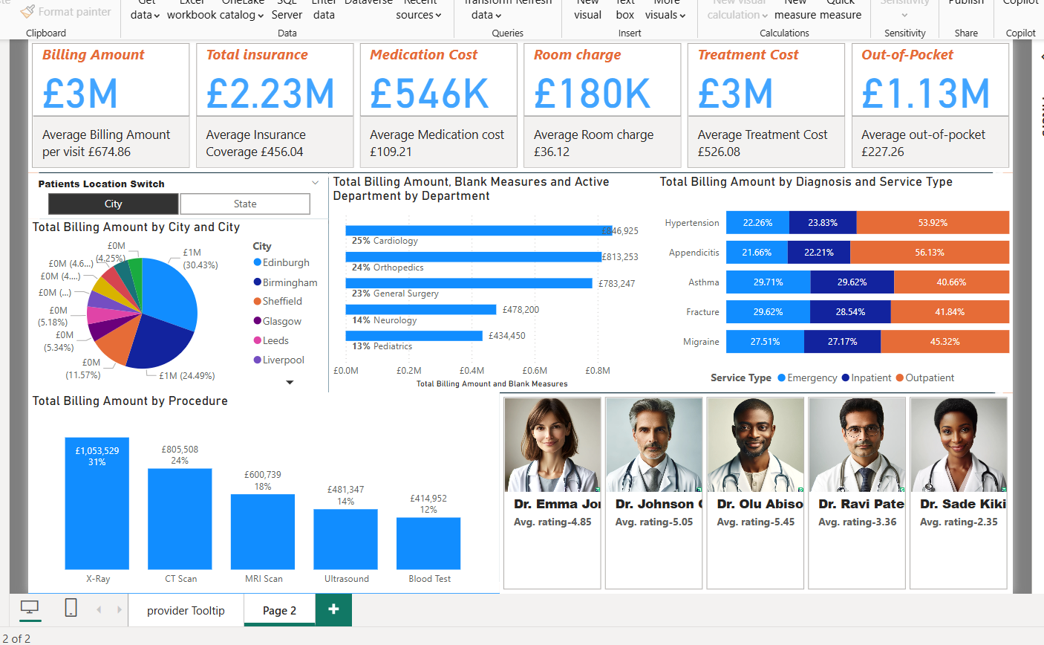

**The web application Trends in the healthcare market's home page or welcome page**

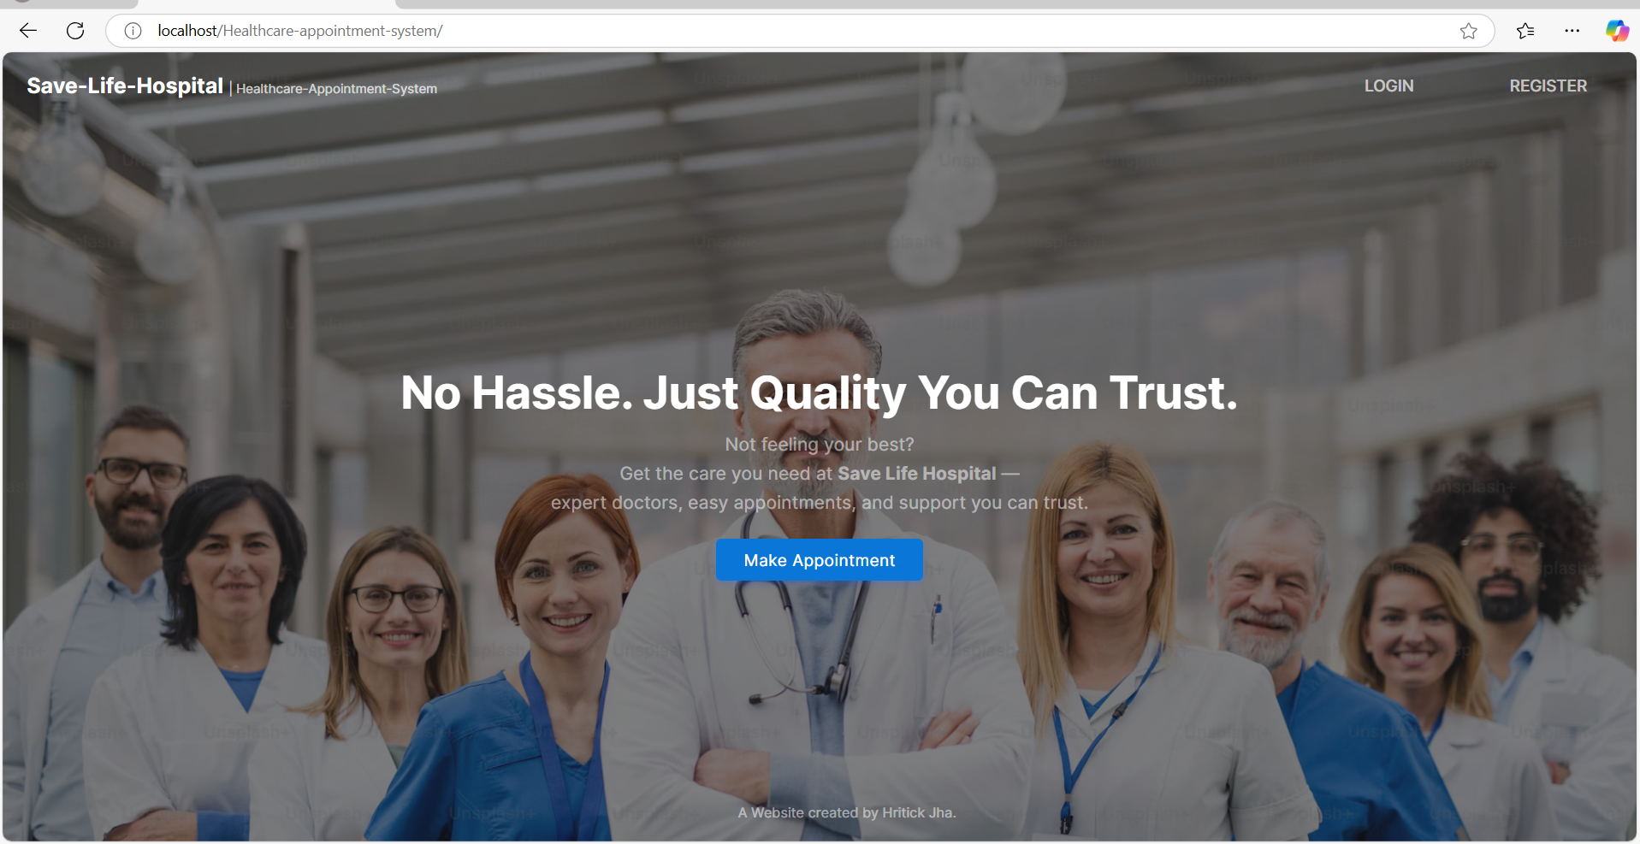

**Login page**

**Sign up page**

**Home page for patients**

**Doctor list displayed in patient page**

**Scheduled Sessions page for the patient**

**Appointment booking section for the patient**

**Setting options for the patient**

**Patients page to edit the information**

**Patients page to view the information**

**Patients’ option to delete the account**

**Doctor home page to view**

**Appointment page for doctor**

**Scheduled session page for doctors**

**Patients’ history page for doctor**

**Account setting page for the doctor**

**Home page for admin**

**Doctor details page for admin**

**Schedule manager page for admin**

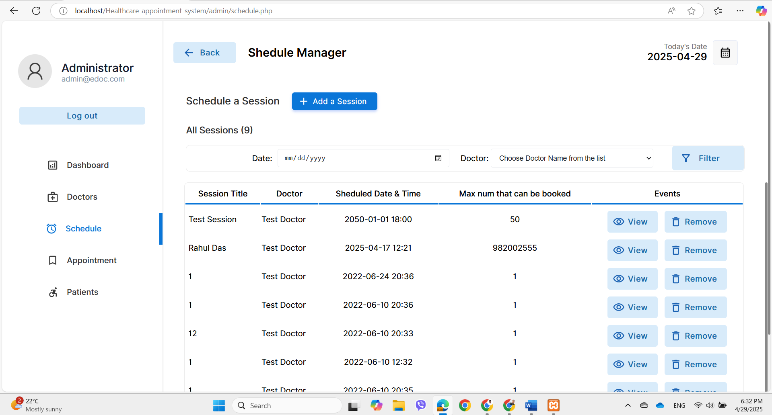

**Appointment management page for the admin**

**Patient details page for admin**

**View page of the activities for the admin**

